 |  | Attachment J  Conceptual Design Documents
New Stockton Courthouse
Superior Court of California

County of San Joaquin

Note: The drawings included herein are very preliminary and were prepared to test the project program and to verify the capacity of the sites. They are included only to convey the anticipated general character and scope of the project, and are subject to substantial revision.

 |  | 

Proposed Site – Hunter Square

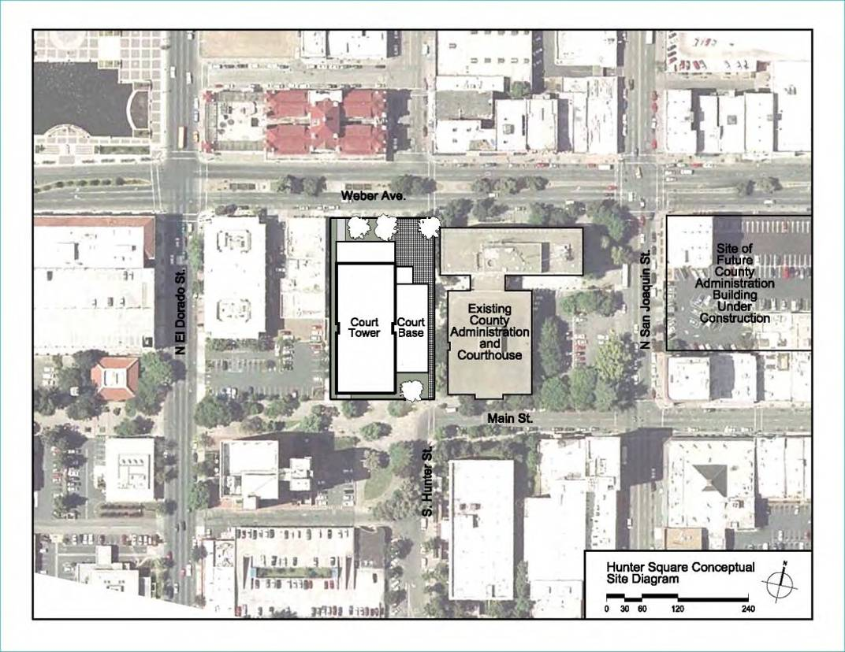
Hunter Square - Test Fit

Hunter Square Expanded - Test Fit
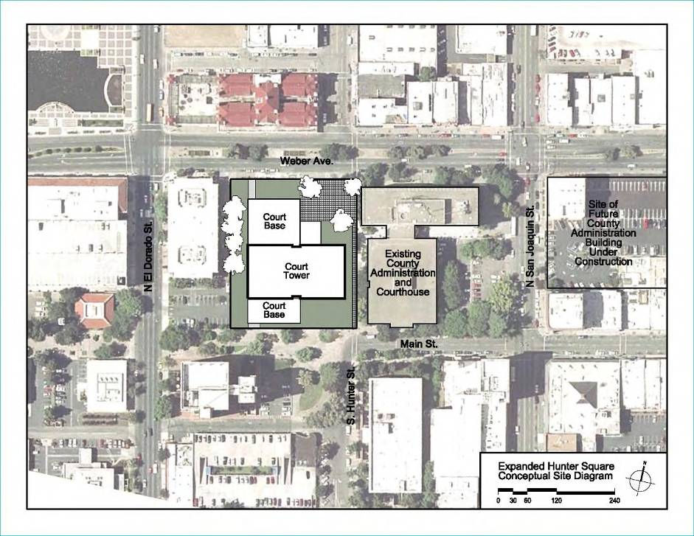

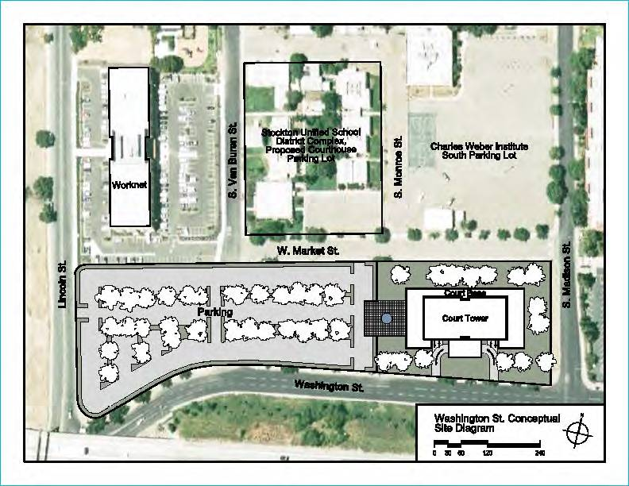
Washington Street - Test Fit (Alternate Site)

